# Classification Tools

## Purpose

This module offers a set of functions for unsupervised classification task. These functions are:

* Perform a separability analysis on a classified image
* Perform separability analysis on a list of classified images
* Automated task to classify an image stack with the ISOdata unsupervised classification, followed by a separability analysis on the result. This is repeated for user specified range of the number of classes.

## Installation

Install the .sav files in the save_add folder (see also [ENVI .sav files: Installation and configuration](http://www.itc.nl/personal/nieuwenh/installations.html).

_nrsmenu.sav Define NRS menu item in ENVI

nrs_Utils.sav Library with utility routines

nrs_class_tools.sav The actual software

## Usage (gui)

|  |  |
| --- | --- |
| nrs_separability_gui | Start the user interface of the separability analysis for a single classified image. |
| nrs_separmulti_gui | Start the user interface of the separability analysis for multiple classified images. |
| nrs_autoclus_gui | Start the user interface of the automated unsupervised classification tool |

Alternatively the commands can be started from the ENVI menu: ‘NRS | Classification’:

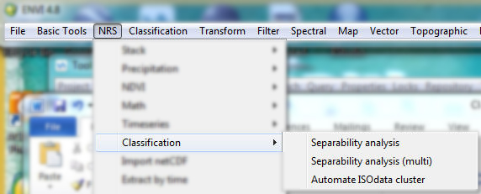

### Separability analysis (Single)

Menu option is ‘NRS | Classification | Separability analysis, the command line is ‘nrs_separability_gui’. This function calculates a statistical distance measure between classes where any combination of bands can be used. SA computes divergence as the distance measure and uses all bands. The formula used for divergence is from (Swain and Davis 1978), and is calculated for each signature pair (i, j):

$D_{ij}=\frac{1}{2}tr\left(\left(C_{i}-C_{j}\right)\left(C_{j}^{-1}-C_{i}^{-1}\right)\right)+\frac{1}{2}tr\left(\left(C_{i}^{-1}+C_{j}^{-1}\right)\left(µ_{i}-µ_{j}\right){\left(µ_{i}-µ_{j}\right)}^{T}\right)$ ${index}_{min}=\left(\frac{x-x_{min}}{x_{max}-x_{min}}\right)$ (1)

Where:

Dij Divergence for signature pair (i, j)

Ci Covariance matrix for signature i

C-1 Inverse matrix

CT Transpose of matrix

µi Mean of signature i

tr() Trace matrix function (Sum of elements on the matrix diagonal)

The user interface is shown below:

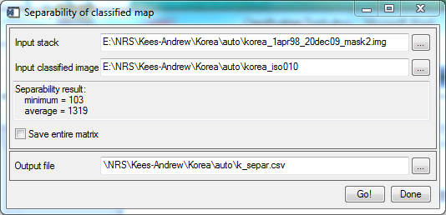

Explanation of all the fields:

|  |  |
| --- | --- |
| Input stack | Select an input image |
| Input classified image | Select a classified image |
| Separability result | Will show the minimum and average divergence values after the calculation finishes |
| Save entire matrix | If switched on the software will save the entire divergence matrix to a file; The name is built using the name of the output with a postfix of ‘_mat’ |
| Output file | The filename of the output table. |

Note: The software output the result as one record with the fields: number of classes, minimum separability and average separability. The output will be always appended to the output file if it exists, thus allowing multiple runs to end up in the same file.

During the calculation one progress indicator is displayed, showing the progress of the covariance calculation (visible with the title *Auto cluster*) followed by the progress of the separability, see the figures below:

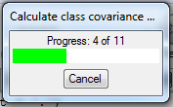 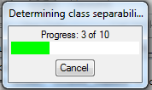

### Separability analysis (Multiple)

Menu option is ‘NRS | Classification | Separability analysis (multi), the command line is ‘nrs_separmulti_gui’. The basic function is exactly the same as for ‘Separability Analysis (single)’ (see above), except that it expects a list of classified images.

The user interface is shown below:

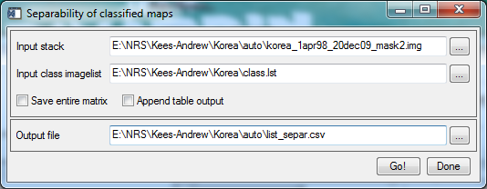

Explanation of all fields:

|  |  |
| --- | --- |
| Input stack | Select an input image |
| Input class imagelist | Select the file with the names of the classified maps |
| Save entire matrix | If switched on the software will save the entire divergence matrix to a file; The name is built using the name of the output with a postfix of ‘_mat’ |
| Append table output | If switched on, this will cause the output results to be appended to an already existing output table; if switched off the output will overwrite existing tables. |
| Output file | The filename of the output file. |

Note: the input class imagelist file expects the complete name and path of the classified images, one line per file; the software will only look at classified images, other image types are ignored.

During the calculation two progress indicators are displayed, one showing the progress with respect to the list of classified images (visible with the title *Analysis classified images*), and one with the progress of the separability, see the figure below:

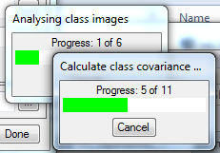

### Unsupervised Classification and Separability Analysis

Menu option is ‘NRS | Classification | Automate ISOdata clusters, the command line is ‘nrs_autoclus_gui’. This function takes a range of number of classes, and for each number of classes classifies the input image stack using ISOdata clustering, followed by a separability analysis (as above)

The user interface is shown below:

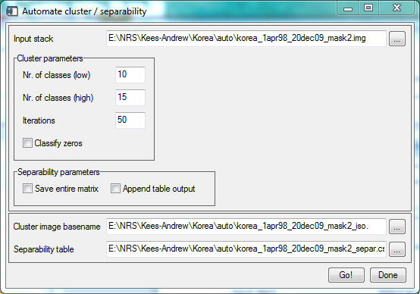

Explanation of all fields:

|  |  |
| --- | --- |
| Input stack | Select an input image |
| **Cluster parameters** |  |
| Nr. of classes (min) | Choose the start number of classes |
| Nr. of classes (max) | Choose the end number of classes |
| Iterations | Set the number of iterations for the ISOdata clustering. |
| Classify zeros | If switched on, zeros are also considered in the classification. If switched off zeros are interpreted as *Unclassified*, In which case a mask image is generated |
| **Separability parameters** |  |
| Save entire matrix | If switched on the software will save the entire divergence matrix to a file; The name is built using the name of the output with a postfix of ‘_mat’ |
| Append table output | If switched on, this will cause the output results to be appended to an already existing output table; if switched off the output will overwrite existing tables |
| **Output parameters** |  |
| Cluster image basename | The name used for the output of the classifications. The actual name is the basename with the number of classes generated as a postfix |
| Separability table | The filename of the output file. |

When the *classify zeros* if off, an image containing the mask will be generated and subsequently used by the ISOdata classification. The name is built from the name of the input image stack with a postfix of ‘_mask’.

The ISOdata clustering is forced to create the exact number of classes. The ENVI version is used, and is initialized with these settings (for additional information see the ENVI manual, topic CLASS_DOIT):

|  |  |  |
| --- | --- | --- |
| *Parameter* | *Value* | *Description* |
| change_thresh | 0.0 | make sure that classification is running through all iterations, and does not stop earlier |
| iso_merge_pairs | 2 | max number of classes to merge in an iteration |
| iso_merge_dist | 0.0 | prevent merging within an iteration |
| iso_min_pixels | 1 | min number of pixels in a class |
| iso_split_smult | 1.0 | multiplier for standard deviation |
| iso_split_std | 0.0 | don't use split option |

During the calculation three progress indicators are displayed, one showing the progress with respect to the range of number of classes (visible with the title *Auto cluster*), one for the ISOdata clustering, and one with the progress of the separability, see the figures below:

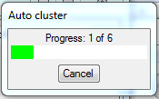 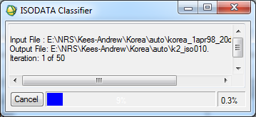

 

### References:

Swain, P. H. and S. M. Davis (1978). Remote sensing : the quantitative approach. New York etc., McGraw-Hill.